42028: Deep Learning and Convolutional Neural Network
Assignment 3: Project Report

Project Title: Identify Landmarks using Image Classification

Team Name and Project Number: Where’s Waldo – Group 24
Team Members:
- Tung Linh Ha – 14285872
- Irvin Ng Yee Hin – 14082426
- Zi En Tham - 14375253
Date: 29 May 2023

Table of Contents
Table of Contents 2
Abstract 4
1. Introduction and Background 4
1.1 The problem 4
1.2 Motivation 5
The connection between the artist and the user 5
Artist Recognition and Appreciation 5
1.3 Application 6
User Experience and Features 6
CNN Architecture and Image Classification 6
Artist Recognition and Information Retrieval 6
Mobile Accessibility and Real-time Access 6
Graphical User Interface (GUI) 6
1.4 Dataset 7
Firebase 8
2 Overview of the architecture/system 9
2.1 Workflow Diagram 9
2.2 CNN Architecture Design 10
2.3 GUI Design 12
Main Screen 12
Result Screen 14
Map Screen 15
3 Results and Evaluation 17
3.1 Experimental Settings 17
3.2 Pre-Processing 18
3.3 Experimental Results 19
3.4 Limitations 22
Data Availability and Quality 22
User Experience 22
GUI Features 22
Model Limitation 22
4 Discussion and Conclusions 23
5 References 25
Appendices 26
A. Individual Contribution 26
Tung Linh Ha 26
Irvin Ng Yee Hin 26
Zi En Tham 27
B. Individual Contribution Split 27
C. Resources 28
Workflow Diagram 28
ResNet50 Architecture 28
MobileNetV3Small Architecture 28

Abstract
This study discusses and showcases an image classification app developed for the VIVID Light Festival in Sydney, Australia. The app was design to enhance the festival experience by allowing users to identify and learn about famous landmarks and art installations along with their artists showcased during VIVID. It utilises a convolutional neural network (CNN) architecture for accurate image classification of vibrant light displays. The dataset comprises diverse landmark images from various areas of Sydney. The report provides an overview of the architecture, including the CNN design and graphical user interface (GUI). Experimental results demonstrate the app's effectiveness in identifying landmarks and providing relevant information. The project contributes to the VIVID experience by offering a user-friendly tool for identifying landmarks and accessing information about captivating light installations and their artist.

1. Introduction and Background
The VIVID Light Festival in Sydney, Australia, showcases breathtaking light displays and art installations that captivate audiences worldwide. This project introduces an innovative image classification app designed to amplify the festival experience by spotlighting the artists behind the art installations. The app's primary motivation is to provide a platform for these talented artists to be recognised and appreciated for their remarkable contributions. By utilising a robust convolutional neural network (CNN) architecture, the app enables users to quickly identify famous landmarks and discover additional works by the respective artists showcased during VIVID. With a diverse dataset comprising landmark images from various areas of Sydney, the app offers an immersive journey that allows users to explore the rich tapestry of artistry displayed throughout the festival. By fostering a deeper connection between artists and audiences, the app aims to celebrate creativity, promote artist recognition, and create a meaningful experience that encourages users to engage with the vibrant world of VIVID on a whole new level.

1.1 The problem
Through this project and the development of the app, our group would like to address two main problems that have come to our attention when researching, one of which is related heavily to VIVID Sydney, which in turn inspired us with the theme of our project.
The first issue that has come to our attention through our experience with VIVID Sydney is that while people enjoy sightseeing and taking pictures of the artworks, they do not necessarily know about the artists and their inspiration. This concept is crucial as it would show appreciation and recognition to the artist and their hard work. Our project aims to build a bridge that will connect the gap between the availability of this information and the festivalgoers. Having this information obtainable at the tip of the finger on their phone would encourage more festivalgoers to learn about the people behind these incredible projects.
The second problem we aim to address is providing an accessible "tourist guide" to everyone. When a person visits a new place, they usually search on the Internet for information about that city, and usually, what would be displayed will be the iconic locations in that city. However, this would guarantee that many other beautiful and worth-mentioning sculptures will be overlooked. For instance, when discussing Sydney, people always mention the iconic Sydney Opera House or the Harbour Bridge. Other places like Queen Victoria Building, with its beautiful architecture from the 19th century, will not be in anyone's mind. Hence, we would like to promote more historical and cultural places to tourists and people alike and enhance their experience with Sydney.

1.2 Motivation
The motivation behind this project stems from the desire to recognise and appreciate the talented artists who contribute to the captivating art installations showcased during the VIVID Light Festival in Sydney. The festival serves as a platform for these artists to showcase their creativity and talent, yet their contributions often go unnoticed amidst the event's grandeur. By developing an image classification app that highlights the artists behind the art installations, we aim to bring their work to the forefront and provide a platform for recognition.

The connection between the artist and the user
Through the app, we aim to bridge the gap between artists and festivalgoers, creating a deeper connection and fostering a greater appreciation for their artistry. By utilising a robust convolutional neural network (CNN) architecture, the app enables users to identify famous landmarks and access information about the respective artists. This provides festivalgoers with a richer and more meaningful experience and empowers the artists by giving them the recognition they deserve.

Artist Recognition and Appreciation
The motivation behind this project goes beyond the VIVID Light Festival itself. It is a celebration of creativity and artistic expression to promote artist recognition and cultivate a greater understanding and appreciation for the diverse art forms represented at the festival. We aim to create a lasting impact and inspire future generations of artists and art enthusiasts by bringing the artists and their work into the spotlight.
Overall, the motivation behind this project is driven by the desire to recognise, appreciate, and celebrate the artists who contribute their talents to the VIVID Light Festival and to create a deeper connection between artists, their art, and the audience.

1.3 Application
The application, designed to enhance the festival experience, provides users with a platform to identify landmarks and learn about art installations and their artists. By using a convolutional neural network (CNN) architecture for accurate image classification, the app offers festivalgoers an interactive tool to capture images, access information, and engage with the vibrant world of the festival.

User Experience and Features
The app's user-friendly interface and intuitive design ensure festivalgoers a seamless and enjoyable experience. Users can easily capture images, identify landmarks, and explore detailed information about the artists and their works. The app's key features enable effortless navigation and interaction, enhancing the user experience.

CNN Architecture and Image Classification
The application leverages a robust CNN architecture for precise and reliable image classification. The CNN model implemented in the app employs advanced techniques and algorithms to identify landmarks amidst vibrant light displays accurately. This ensures the app can deliver accurate and informative results to users.

Artist Recognition and Information Retrieval
A significant aspect of the application is its promotion of artist recognition and appreciation. Festivalgoers can delve into the artists' backgrounds and gain insights into their creative process. By highlighting the artists behind the art installations, the app fosters a deeper connection between artists, their works, and the audience, enriching the festival experience.

Mobile Accessibility and Real-time Access
Designed for mobile devices, the app offers festivalgoers convenient accessibility during the event. Users can access real-time information about landmarks and art installations, enhancing their understanding and appreciation of the festival. The app's mobility ensures that users can engage with the festival's vibrant atmosphere on the go.

Graphical User Interface (GUI)
The app's graphical user interface (GUI) features an intuitive layout, making it easy for users to navigate, capture images, and retrieve information effortlessly. Interactive and visually appealing design elements enhance the user experience, creating a visually immersive and engaging interface.
The application's seamless integration of image classification, artist recognition, and real-time access to information contributes to an enhanced VIVID Light Festival experience. By providing festivalgoers with a unique and engaging tool, the app facilitates the exploration and appreciation of VIVID's vibrant world while promoting artist recognition and fostering a deeper connection between artists and the audience.

1.4 Dataset
The dataset used in this project comprises of 14 landmarks and art installations in Sydney. It features famous landmarks such as Sydney Opera House, Harbour Bridge, Queen Victoria Building and more. The dataset also includes some art installations from Vivid Sydney 2022 such as Macula, Ephemeral Oceania, and Convergence. Figure 1 shows the list of landmarks or art installations in the dataset prepared.
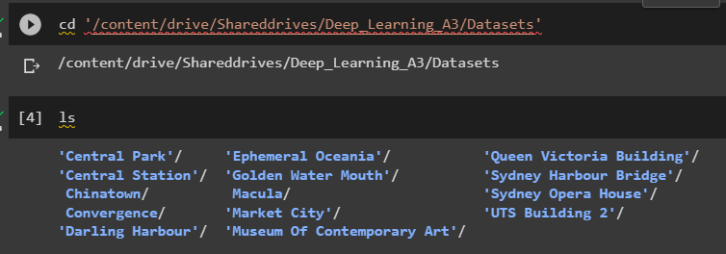
Figure 1: List of Dataset
The images gathered for the dataset are collected manually. To ensure the dataset’s relevance to Vivid Sydney, images were chosen based on their resemblance to the festival's vibrant lights and artistic displays. Data collection method involved recording from multiple devices with a general direction, capturing the captivating night-time ambience. Additional data were collected from relevant websites through manual image capture and web scraping. The dataset consists of approximately 1931 images in total.
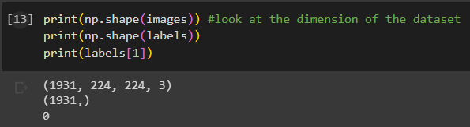
Figure 2: Size and shape of dataset
With that, the team hopes to create a vast variety of angles for each class. This ensures that the model will be able to learn the characteristics of the landmarks and art installations from different angles and image quality. As illustrated in Figure 3, the sample image from each class is displayed.
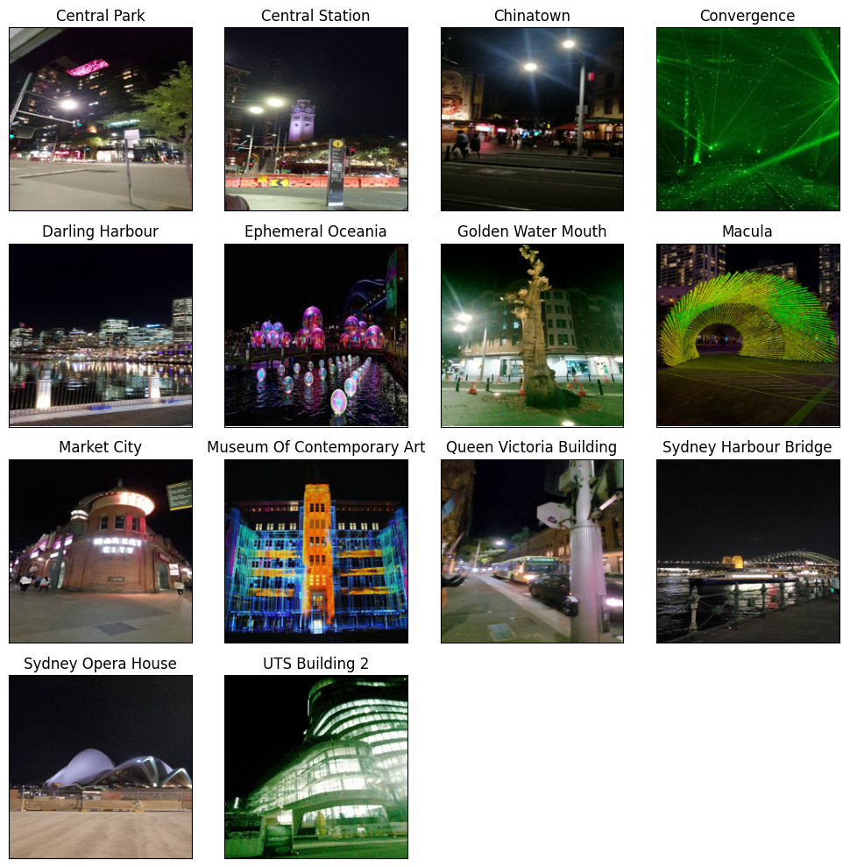
Figure 3: Sample Images of Dataset

Firebase
Firebase has been implemented as the backend solution for storing and retrieving artist information and dataset details in the app. The Firebase real-time database ensures secure and efficient data storage, enabling users to access up-to-date information about artists and their works during the VIVID Light Festival. The database below stores artist names, landmark names, landmark details, landmark address, and the landmarks’ coordinates, providing users a comprehensive understanding of the artistry. With Firebase's real-time synchronisation capabilities, any updates to the backend are instantly reflected in the app, ensuring users always have the latest and most accurate information. This implementation enhances the user experience by enabling seamless and reliable access to the rich content associated with the festival.
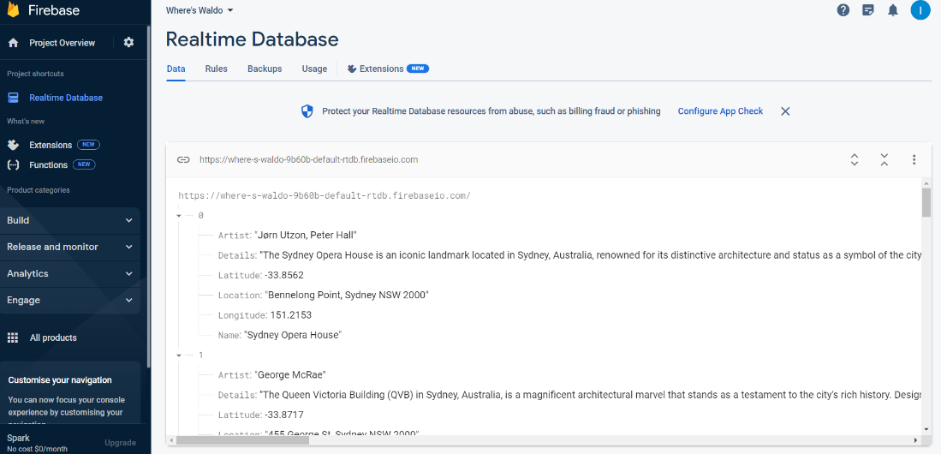
Figure 4: Firebase Dataset

2 Overview of the architecture/system
The development of landmark classification application involved several major phases. After determining the list of landmarks and goal of applications, the team first began with data collection and data cleaning. Subsequently, experiments with various CNN models and evaluation are performed to select the best model for the classification task. Finally, the team set up a database in Firebase to store the necessary information about each class. Firebase is chosen for data storage because it allows seamless deployment and maintenance. The information stored in the Firebase will be retrieved to display it on the GUI when needed.
There are two main activities available in the mobile application. The user can upload a photo from their gallery or by taking a photo. The application will then process the user’s photo and classify the photo into one of landmarks. A successful classification should display the correct landmark’s name and details. There is also a button that will redirect the user to Google Map if the user wants to navigate to the landmark. The user is also able to view the overall landmarks in the map interface. This map interface will contain markers of all the available landmarks and art installations. By clicking the marker, the detailed information about the landmark and an option to redirect the user to Google Map for further navigation.
The workflow, CNN architecture design, and GUI design, among other aspects will be discussed in detail in this section. By presenting a clear understanding of the architecture/system, this overview provides a foundation for comprehending the subsequent sections that delve into each component in more detail. With a well-designed architecture/system, the image classification app can offer users a seamless experience while exploring the VIVID Light Festival's vibrant landmarks and art installations.

2.1 Workflow Diagram
A Workflow Diagram is a crucial development step in designing an application or system. It visualises the flows of the app and how all the components link to each other. In this experiment, the workflow diagram was divided into nine fields, displayed with different colours for easier visualisation. The first field is the "User" field, which initiates the sequence of activities by opening the applications. There are three possible outcomes for these sequences:
- Return to Home Screen: This outcome is usually triggered by getting out of the prediction result displayed over the Home screen.
- Return to Map Screen: This outcome will be achieved by returning to the map screen after clicking out of the information overlay.
- Display routes to the location: This outcome is shown in the Google Map application if the user chooses to find their way to the area. This outcome will display the site on their maps, and they can save it or find a route to the place.
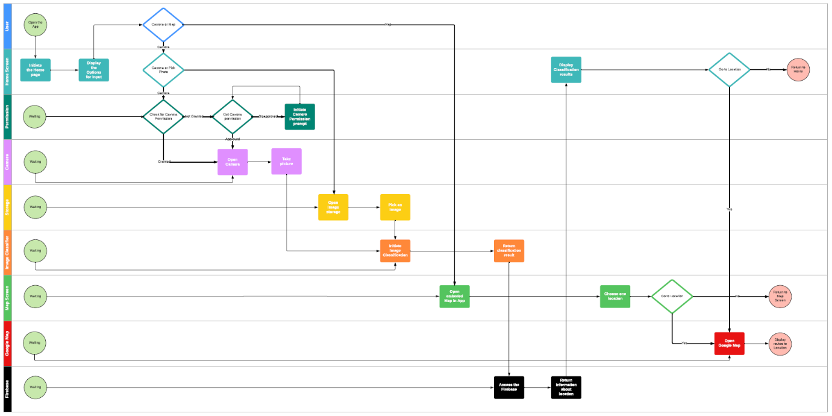Figure 5: Workflow Diagram
Due to the size of the diagram, a copy of the original version has been attached in the Appendix C for further investigation.

2.2 CNN Architecture Design
For the CNN architecture design, we explored multiple models such as MobileNetV3 and ResNet50 to determine the most suitable option for our image classification app. Multiple experiments are conducted to compare their performance, considering accuracy, computational efficiency, and model size.
ResNet50 is a deep convolutional neural network architecture with 50 layers. It introduced residual connections, alleviating the vanishing gradients in deep networks. The architecture consists of multiple residual blocks containing two or three convolutional layers with batch normalization and ReLU activation. A skip connection is used to add the input to the output of each residual block, allowing gradients to flow directly. Towards the end, global average pooling reduces spatial dimensions, followed by fully connected layers for classification. ResNet50 has achieved state-of-the-art performance in computer vision tasks and is widely used as a backbone network. Its depth and residual connections enable it to capture complex features and learn intricate representations. The model summary can be viewed in Appendix C. (He et al., 2015)
MobileNetV3 Small is a lightweight convolutional neural network (CNN) architecture designed for mobile and embedded devices. It focuses on achieving high efficiency while maintaining reasonable accuracy. MobileNetV3 Small utilizes separable convolutions, which split the traditional convolution into a depth-wise convolution and a point-wise convolution, reducing the number of parameters and computational complexity. It also incorporates a combination of inverted residuals and linear bottlenecks, efficiently capturing spatial and channel-wise information. The architecture includes multiple stacked blocks with different expansion and stride values, followed by global average pooling and a fully connected layer for classification. MobileNetV3 Small is optimized for resource-constrained environments, offering faster inference speed, lower memory usage, and smaller model size than heavier networks like ResNet50, making it suitable for real-time mobile and embedded devices applications. The model summary can be viewed in Appendix C. (Howard et al., 2019)
After careful evaluation, we found that ResNet50 exhibited promising results in accuracy and efficiency. Therefore, the team selected ResNet50 as the base architecture for our model. To mitigate overfitting and improve the model's robustness, we introduced multiple L2 regularises in the architecture. These regularises help control the model's complexity and prevent it from memorising the training data.
 | ResNet50 | MobileNetV3Small
Train and Validation Accuracy | 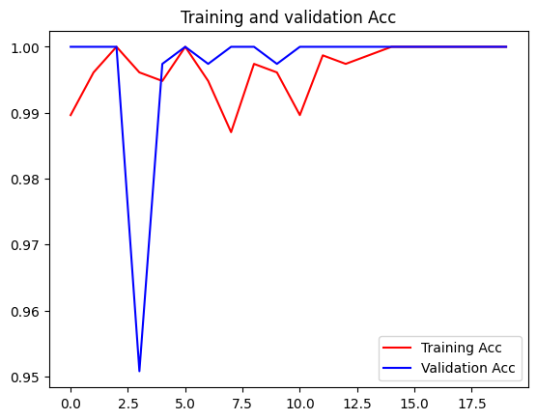 | 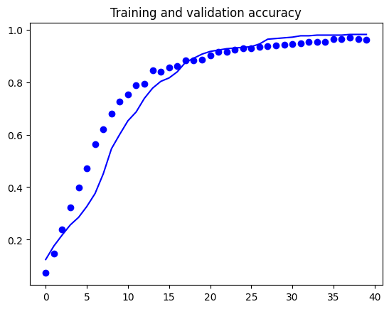
Train and Validation Loss | 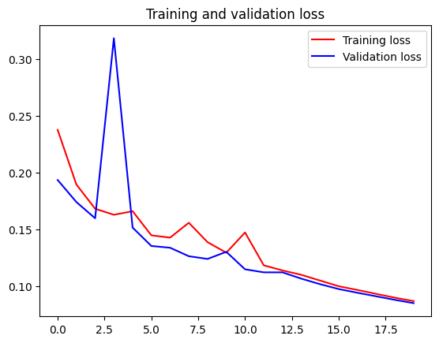 | 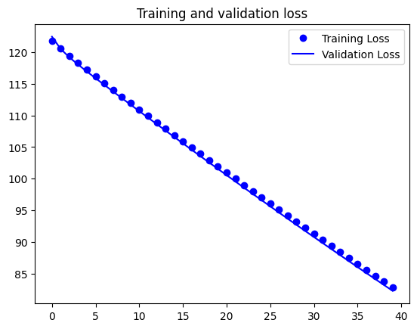
Test Accuracy and Loss | - Accuracy: 1.0  - Loss: 0.08511854708194733 | - Accuracy: 0.9766839146614075  - Loss: 82.31669616699219
Table 1: Accuracy and Loss Comparison for ResNet50 and MobileNetV3Small

2.3 GUI Design

Main Screen
The main screen of our app features a visually appealing layout with a prominent display of our app logo in the centre. The screen comprises two buttons and two navigation screens designed to provide intuitive functionality for our users. The first button, labelled "Take Photo," enables users to capture pictures directly using their camera. This feature is a convenient way to input images for further processing within our app. The second button, labelled "Choose Photo," allows users to access and select images from their gallery, providing flexibility and convenience in choosing input images.
The navigation screens have two options: the "Home" screen and the "Map" screen. The “Home” screen is where the options to take photo or choose photo are shown and the main screen where the app will be loaded to. This feature facilitates real-time image input, ensuring a seamless and responsive user experience. On the other hand, choosing the "Map" option leads users to a screen displaying a map interface. This map showcases locations pinned based on the datasets we have incorporated into our app, most of which will be known VIVID Sydney locations. By providing this map navigation pane, users can visually explore the geographical distribution of our dataset, adding an interactive and informative dimension to the app.
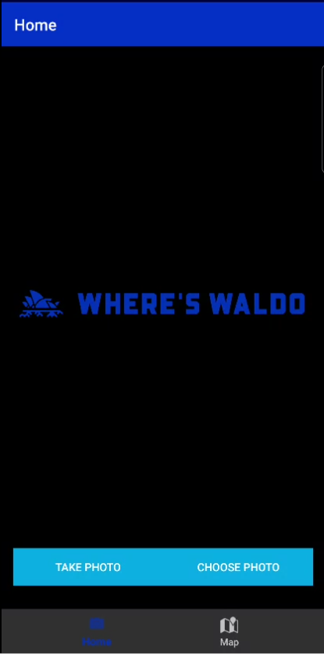
Figure 6: Main Screen
The image in Figure 7 depicts the dedicated camera screen when the user selects the "Take Photo" button. This screen provides a user-friendly interface with essential controls and options for capturing photos within our app. Users can preview and capture images using the device's camera functionality, while intuitive gesture controls allow for zooming. Once captured, the photo seamlessly integrates into the app for further processing or analysis.
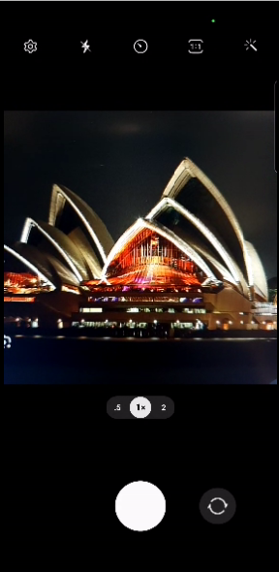
Figure 7: Camera Screen
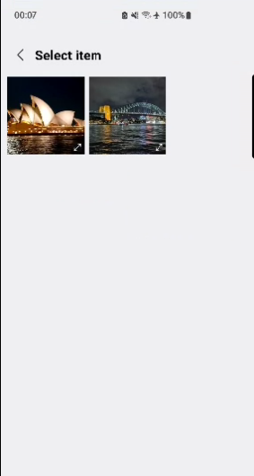
The image in Figure 8 illustrates the gallery screen when the user selects the "Choose Photo" button. This screen provides the phone’s image storage interface for browsing and selecting images from the user's gallery. Users can conveniently scroll through thumbnails of their photos, tap on the desired image to select it, and seamlessly integrate it into the app's workflow for further use.
Figure 8: Gallery Selection Screen

Result Screen
When an image is selected in the app, the screen displayed is transformed from the initial state where the logo is prominently featured. Instead, the chosen picture, either captured using the camera or selected from the gallery, replaces the logo on the screen. This dynamic update allows users to immediately visualise the image they have taken or chosen as the central focus of the app's interface. By replacing the logo with the selected image, the app personalises the user experience and provides a visually engaging display that showcases the user's input front and centre.
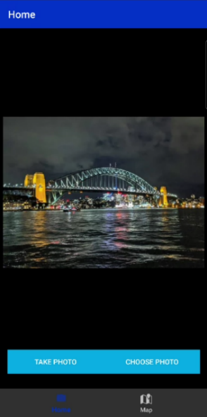
Figure 9: Result Main Screen
After selecting the image, the app runs the TFLite CNN model to scan the input and extract relevant information. The observed result and details about the artist associated with the artwork are then generated and displayed on the screen. To make this information visually appealing, an image of the result was set to displayed using Firebase. This process happens automatically and almost instantaneously as the image is chosen. This gives users valuable insights into the artwork they have captured or selected. Additionally, if the image corresponds to a recognised landmark, an additional "Go" button is presented below the screen. When users tap this button, they are directed to the specified location in the Google Map app, allowing them to explore different options to reach the landmark. This combination of artwork information and landmark navigation enhances the user experience, fostering a deeper appreciation for art and facilitating real-world exploration.
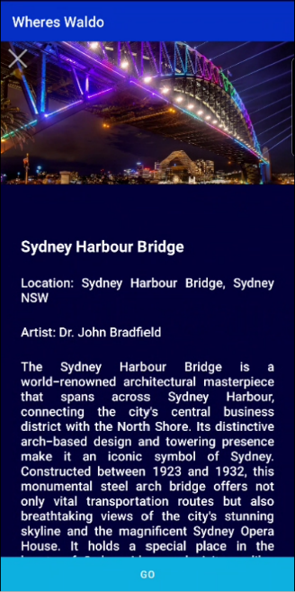
Figure 10: Result Description Screen

Map Screen
The map screen in our app showcases various landmarks that are part of our Firebase dataset. Each landmark is represented on the map by a red pin, giving users a visual reference of their locations. When users tap on a red pin, a pop-up window appears, displaying information about the respective artist associated with that landmark (See Figure 11).
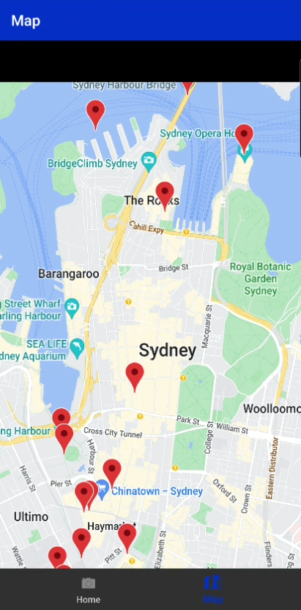
Figure 11: Map Screen
This includes details such as the artist's name, description, and other relevant information. By incorporating this feature, users can easily explore the artists and their works directly from the map interface, fostering a deeper understanding and appreciation of the artistic significance behind each landmark. (Shown in Figure 12).
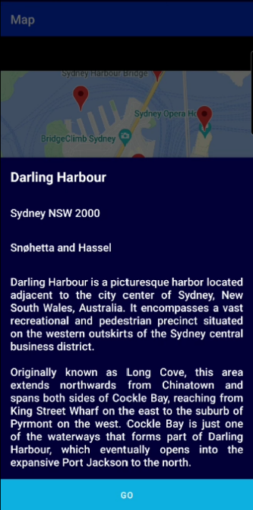
Figure 12: Map Description Screen
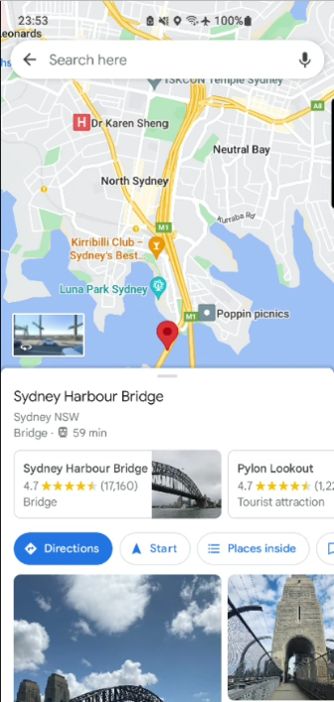
When the user taps the "Go" button on the map screen, the app directly opens the Google Maps app. This seamless integration enables users to be automatically directed to the location of the selected landmark. By using the robust navigation capabilities of Google Maps, users benefit from turn-by-turn directions and real-time traffic updates, ensuring a smooth and efficient journey to the desired destination when they hit the “Go” button.
Figure 13: Google Map Screen
The GUI design section of our project focused on creating a visually appealing and user-friendly interface for our app. We carefully considered the placement and arrangement of elements to ensure an intuitive user experience. The main screen featured our app logo prominently and provided two buttons for taking or choosing photos, offering users flexibility in input images. The camera screen enabled real-time photo capture with essential controls and intuitive gesture functionality. The gallery screen facilitated easy browsing and selection of images from the user's gallery. When an image was selected, it replaced the logo on the screen, creating a personalised experience. The map screen showcased landmarks with red pins and tapping on a pin displayed artist information. Including a "Go" button seamlessly integrated with Google Maps allows users to navigate to selected landmarks easily. Overall, the GUI design prioritised aesthetics, functionality, and user interaction to deliver a visually appealing and intuitive interface for our app.

3 Results and Evaluation
This section presents the results and evaluation of our image classification system for landmarks and art installations at the VIVID Light Festival. We conducted extensive experiments to assess the performance and effectiveness of our system, considering various metrics such as accuracy and loss. The evaluation process involved testing the design on a diverse set of images, including both landmarks and vibrant light displays. By analysing the results, we can gain insights into the system's performance, ability to classify images accurately, and any limitations or areas for improvement.

3.1 Experimental Settings
We followed a standard approach for training and evaluating our image classification model in experimental settings. The dataset was split into training and test sets with a ratio of 60:40, ensuring adequate data for model training and evaluation. We split the test set into validation data with a 50% ratio to further assess the model's performance and prevent overfitting.
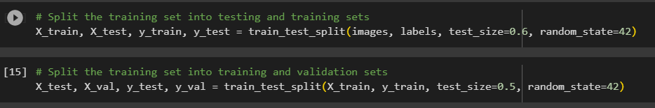
Figure 14: Dataset Splitting
For the model architecture, we utilised the sparse categorical cross-entropy loss function and the Adam optimizer with a learning rate 0.0001. The model was trained using the training data and validated using the validation data for 20 epochs, with a batch size of 20. We monitored the accuracy and loss of both the training and validation sets during the training process to evaluate the model's performance at each epoch.
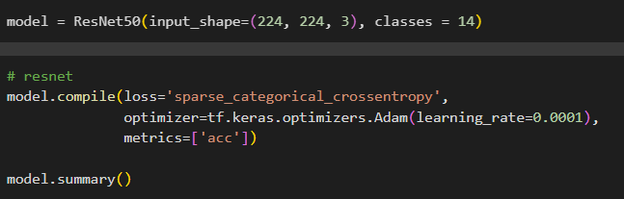
Figure 15: Model Configuration
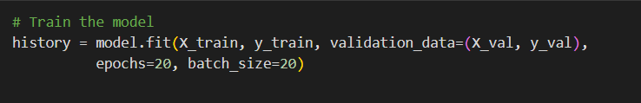
Figure 16: Model Training
To ensure the model reaches its peak performance, we extended the training by 20 epochs, combining 40 epochs. This prolonged training period allowed the model to undergo further refinement and optimisation, enhancing its ability to accurately classify images of landmarks and art installations from the VIVID Light Festival. By continuing the training process, we aimed to maximise the model's performance and ensure that it achieves its highest level of accuracy and generalisation capability.

3.2 Pre-Processing
Before feeding the images into the model, a pre-processing step was performed to ensure compatibility with the CNN architecture. Videos were extracted by frame extraction at a rate of five frames per second and saved as JPG files. All photos in the dataset underwent resizing and conversion to the RGB colour space. Resizing the images to a standardised dimension facilitates efficient processing while converting them to RGB ensures compatibility with the CNN model's input requirements. These pre-processing steps enhance the model's accuracy in classifying vibrant light displays and landmarks during runtime.
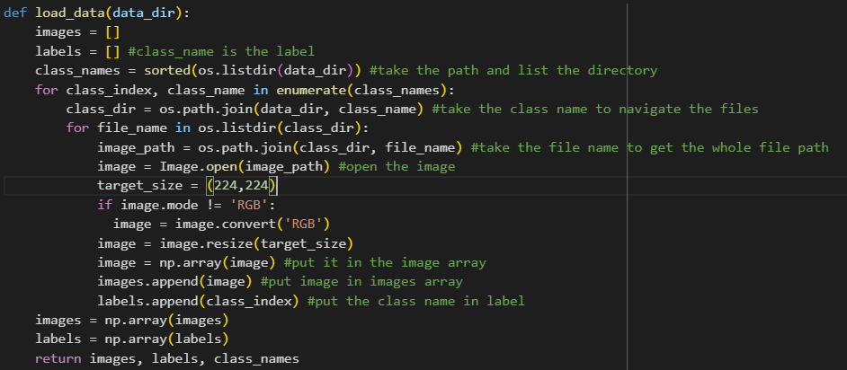
Figure 17: Dataset pre-processing

3.3 Experimental Results
Through extensive testing and evaluation, we observed significant improvements in accuracy compared to the standard ResNet model. The model achieved exceptional results, correctly classifying all the test cases provided, which underscores its effectiveness in accurately identifying landmarks and art installations from the VIVID Light Festival. The results below displayed that the model has predicted all inputs correctly with the testing dataset with an accuracy of 1.0.
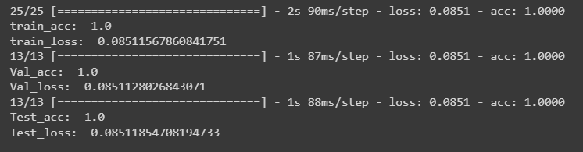
Figure 18: Model Accuracy Result
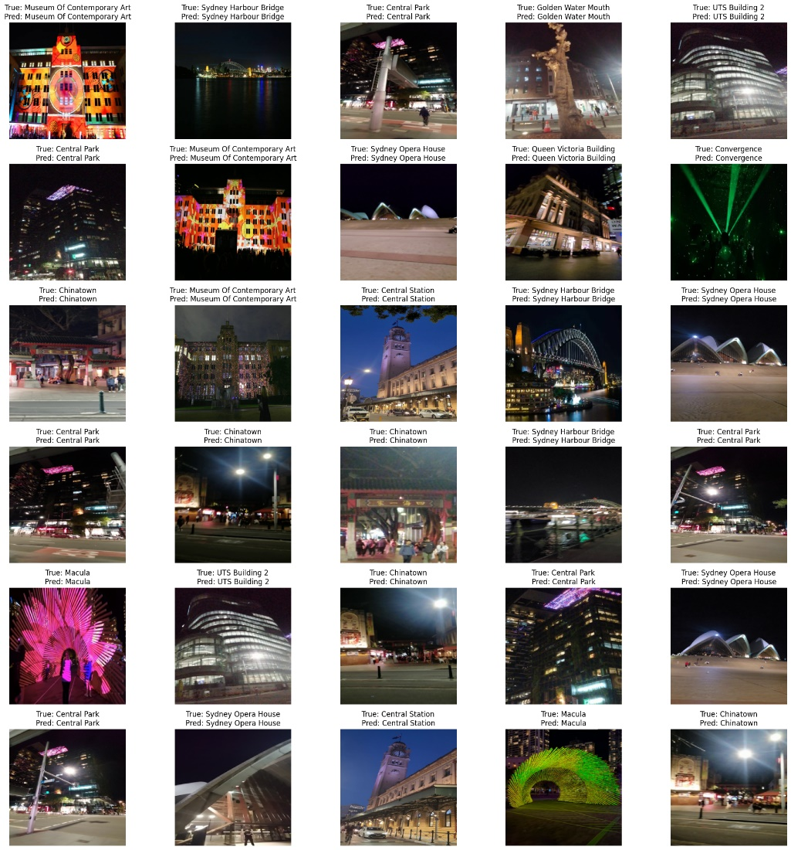
Figure 19: Testing Result
The training results for the model, which had already run for 20 epochs before the displayed results, are as follows:
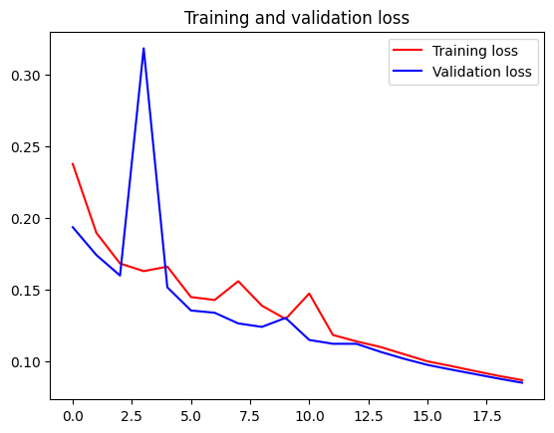
Figure 20: Training and Validation Loss graph
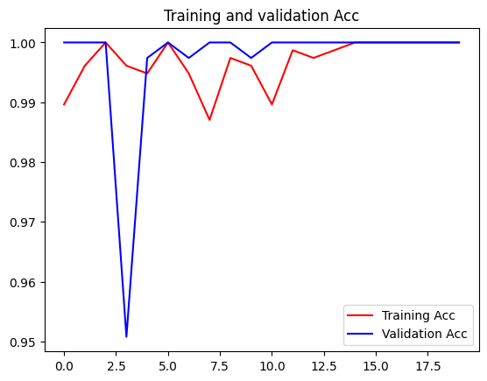
Figure 21: Training and Validation Accuracy Graph
The loss and accuracy metrics for both the training and validation sets are shown for each epoch. The loss value represents the model's deviation from the desired output, with lower values indicating better performance. Accuracy measures the proportion of correct predictions made by the model.
In terms of the loss graph, it can be observed that the loss steadily decreases throughout the epochs for both the training and validation sets. This indicates that the model is gradually improving its predictive capabilities and becoming more accurate.
Regarding the accuracy graph, it is evident that the model achieves exceptionally high accuracy values close to 100% for both the training and validation sets. This suggests that the model has learned to classify the images with high precision, correctly identifying the landmarks or art installations represented in the photos.
The validation loss and accuracy values remain consistently low and high throughout the epochs. This indicates that the model generalizes well to unseen data, as its performance on the validation set is on par with its performance on the training set.
Overall, the training results demonstrate that the model has successfully learned to classify images of landmarks and art installations accurately. It effectively captures the distinguishing features of different landmarks and artists, enabling app users to identify and learn about them during the VIVID Light Festival. The additional 20 epochs refine the model's performance, ensuring its reliability and enhancing the overall user experience.

3.4 Limitations

Data Availability and Quality
The developed system/approach has several limitations that can impact its performance and functionality. Firstly, the availability and quality of the dataset used for training the image classification model are essential factors. Since the dataset is collected manually, there may be limitations in terms of the size and diversity of the dataset. This can affect the model's accuracy, as it heavily relies on having a comprehensive and representative dataset. Additionally, the dataset may not directly consist of images from the VIVID Light show itself but rather fragments of other buildings or landmarks. This limitation arises from the dynamic nature of the event, with different installations and designs changing every year. However, efforts have been made to select images that capture the essence of the VIVID experience.

User Experience
Another limitation to consider is the possibility of user error and input quality. Users may capture images incorrectly, resulting in unclear or distorted images that are challenging to classify accurately. This limitation can be addressed by providing clear instructions and feedback to users, helping them capture high-quality images for better classification results.
The computational resources available on the user's device can also impact the app's performance. The model's processing speed and responsiveness may vary depending on the device's capabilities. While efforts have been made to optimise the model's architecture and implement efficient algorithms, limitations may still arise due to the computational constraints of specific devices.

GUI Features
Furthermore, the app's current version is limited to capturing or selecting images and does not support recording videos. This limitation restricts the app's functionality for users who want to capture and classify moving visuals during the VIVID light show. Future iterations of the app could explore incorporating video recording capabilities to enhance the user experience. It is important to note that our UX/UI skills in designing the app are limited. While efforts have been made to create an intuitive and user-friendly interface, there may be areas for improvement to enhance the overall user experience and interface design.

Model Limitation
Lastly, the availability and limitations of Google Colab GPU resources can impact the training and testing process of the image classification model. The computational resources provided by Google Colab GPU may have specific limitations, which can affect the training time and efficiency of the model.
Addressing these limitations requires a comprehensive understanding of the constraints and challenges involved. Future iterations of the system/approach can focus on improving the dataset quality, refining the user interface design, exploring video recording capabilities, and optimizing the computational resources to provide a more robust and efficient solution.

4 Discussion and Conclusions
In conclusion, this project has successfully developed an image classification app that significantly enhances the VIVID Light Festival experience. The app allows users to effortlessly identify famous landmarks and gain insights into art installations and their respective artists. Powered by a robust convolutional neural network (CNN) architecture, specifically ResNet with L2 regularises, the app achieves exceptional accuracy and reliability in classifying vibrant light displays. Extensive training and validation have demonstrated the model's high performance and accuracy in accurately categorizing the visual elements of the festival.
The app's interface provides a seamless and intuitive experience, enabling users to capture or select images and receive real-time predictions about identified landmarks. By offering a platform for artists to be recognised and appreciated for their remarkable contributions to the festival, the app successfully bridges the gap between artists and festivalgoers. Through access to comprehensive information about the artists and their installations, the app enriches the overall festival experience, fostering a deeper connection between the audience and the art.
Several future extensions and improvements can be considered to enhance the app's capabilities further. Expanding the dataset with a more diverse and representative collection of images from the VIVID Light Festival would significantly improve the accuracy and relevance of the classification results. Collaborating with festival organizers to gather and incorporate images from different installations and years would ensure the app remains up to date, capturing the evolving nature of the event.
Incorporating video recording capabilities into the app would unlock a new dimension of user experience, enabling users to capture and classify dynamic visual displays during the festival in real-time. This feature would provide more immersive and comprehensive knowledge, allowing users to interact with the animated light shows as they unfold.
To optimize the user interface design and overall user experience, conducting user testing and gathering feedback from festivalgoers would be invaluable. By identifying areas for improvement, the app's usability and intuitiveness can be further optimized, encouraging more users to engage with the features and explore the festival through the app. Enhancing the visual appeal and usability of the app will undoubtedly attract more users and amplify their interaction with the festival.
Considering computational resources, exploring cloud-based solutions, or leveraging more powerful hardware resources could significantly enhance the app's performance and speed, particularly during image classification and processing. By addressing potential limitations in computational capacity, users will experience improved responsiveness and a seamless experience when using the app.
For future app plans, it is essential to conduct thorough testing upon its launch to receive user reviews and identify areas for improvement. Engaging a diverse group of festivalgoers and conducting user testing sessions can collect valuable feedback on functionality, usability, and performance. Analysing user reviews and ratings from app stores and social media platforms will provide further insights. This feedback will be invaluable in identifying specific areas, such as user interface design or image recognition accuracy, that require refinement. The app can continually evolve and deliver an exceptional user experience by actively listening to user feedback and implementing necessary updates.
This project has successfully developed an image classification app that significantly contributes to the VIVID Light Festival experience. The app celebrates the creativity and talent of artists by recognizing and showcasing their installations while creating a meaningful and engaging experience for festivalgoers. With the suggested future extensions and improvements, the app has the potential to become an indispensable companion for visitors, inspiring a greater appreciation for the artistry and diverse forms of expression showcased at the Vivid Light Festival.
5 References

He, K., Zhang, X., Ren, S., & Sun, J. (2015). Deep Residual Learning for Image Recognition. https://arxiv.org/pdf/1512.03385.pdf
Howard, A., Sandler, M., Chu, G., Chen, L.-C., Chen, B., Tan, M., Wang, W., Zhu, Y., Pang, R., Vasudevan, V., Le, Q. V., & Adam, H. (2019). Searching for MobileNetV3. ArXiv.org. https://arxiv.org/abs/1905.02244
Thomas.wilhelm@dnsw.com.au. (2020, February 26). Archive. Vivid Sydney. https://www.vividsydney.com/archive/type/light/year/2022

‌
‌

